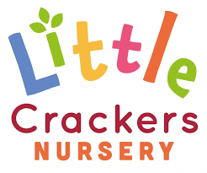 19th June 2020
Weekly News
We would like to wish all our Dads, Daddies, Fathers, Grandads and Grandfathers a Very Happy Father’s Day this Sunday xxx

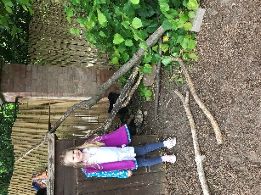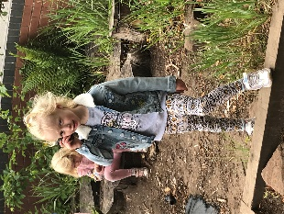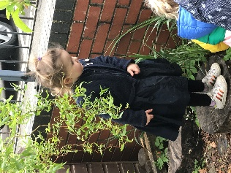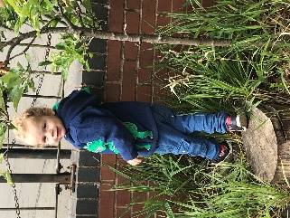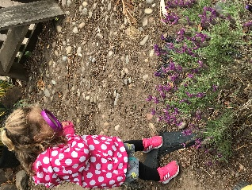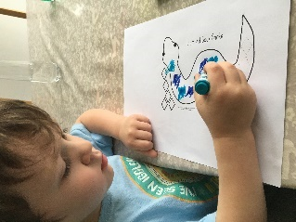

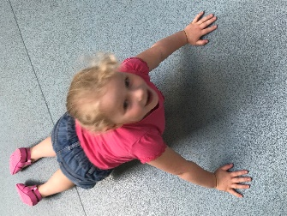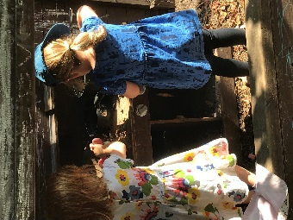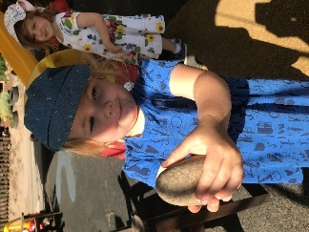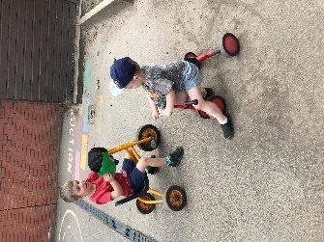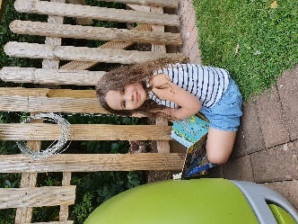

Things to do with Daddy…  Walk in your wellies  Drive to the zoo  Make him some pancakes  Fix him a brew…  Walk the dog  Make chocolate cake  Buy him a paper  Have picnic by a lake…  Wake him up early  Ready for the day  Give him a coffee  And wish him…  Happy Father’s Day! | Puzzle for Daddy…  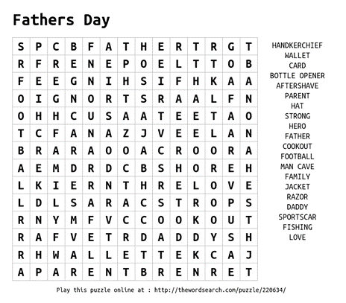

Little Crackers Nursery · Crackley Hall · St Joseph’s Park · Kenilworth · CV8 2FT
Telephone: 01926 514444 · Fax: 01926 514455 · e-mail: littlecrackers@crackleyhall.co.uk
www.crackleyhall.co.uk

Registered Charity Number 1087124 Company limited by guarantee Number 4177718

